ASSINGMENT 2
SOFTWARE REQUIRMENT ENGINEERING
30 – NOVEMBER – 2025

Question # 01: Sequence Diagram & Requirements
a) Write functional and non-functional requirement for “Process Payment”.

Functional Requirements (FR)
FR-P1: The system shall accept payment requests from the checkout flow.
FR-P2: The system shall support multiple payment methods: Card (credit/debit), Mobile Wallet, and Cash on Delivery (COD).
FR-P3: The system shall send payment authorization requests to the Payment Gateway and receive synchronous success/failure responses.
FR-P4: The system shall record transaction details (transaction id, payment method, amount, timestamp, status).
FR-P5: On successful payment, the system shall mark the order as Paid and notify Restaurant and Delivery subsystem.
FR-P6: On payment failure, the system shall notify the customer with error details and provide retry or alternative payment options.
FR-P7: The system shall support refund requests for canceled or failed orders and record refund transactions.

Non-Functional Requirements (NFR)
NFR-P1 (Security): Sensitive payment data shall not be stored in plain text in the system; only tokenized references are stored. Payment flows must be PCI-DSS compliant.
NFR-P2 (Performance): Payment authorization round trip time should be ≤ 5 seconds under normal load.
NFR-P3 (Reliability): Payment retries shall be attempted for transient gateway errors with exponential backoff (configurable attempts).
NFR-P4 (Auditability): All payment events (attempt, success, failure, refund) shall be logged with audit trail for at least 12 months.
NFR-P5 (Scalability): System must handle concurrent payment requests during peak hours without data loss.

b) Draw a Sequence Diagram for “Place Order and Process Payment” including Customer, Restaurant, and Payment Gateway

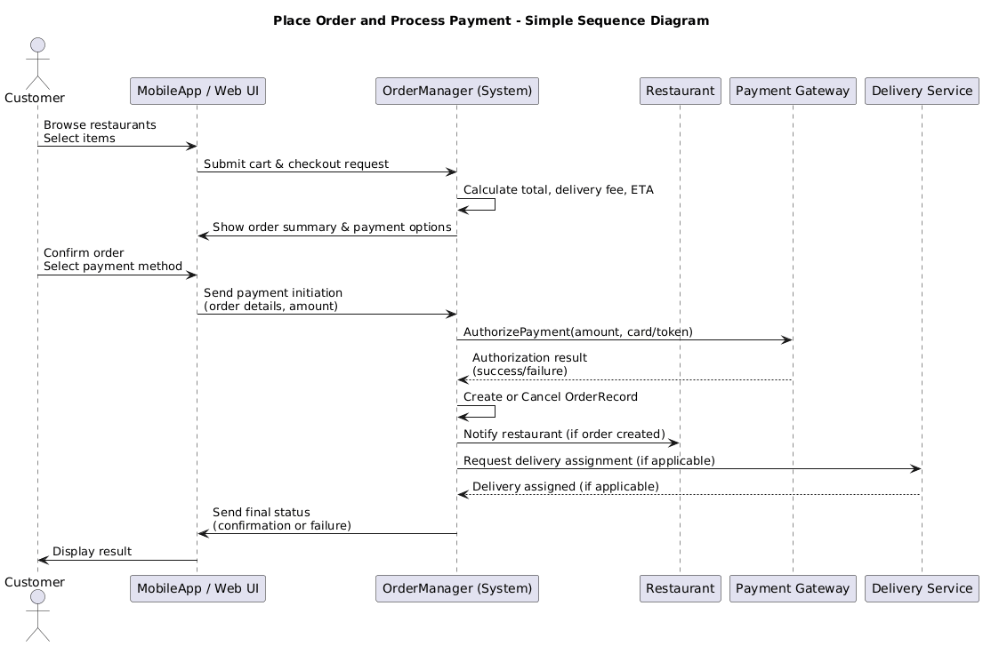
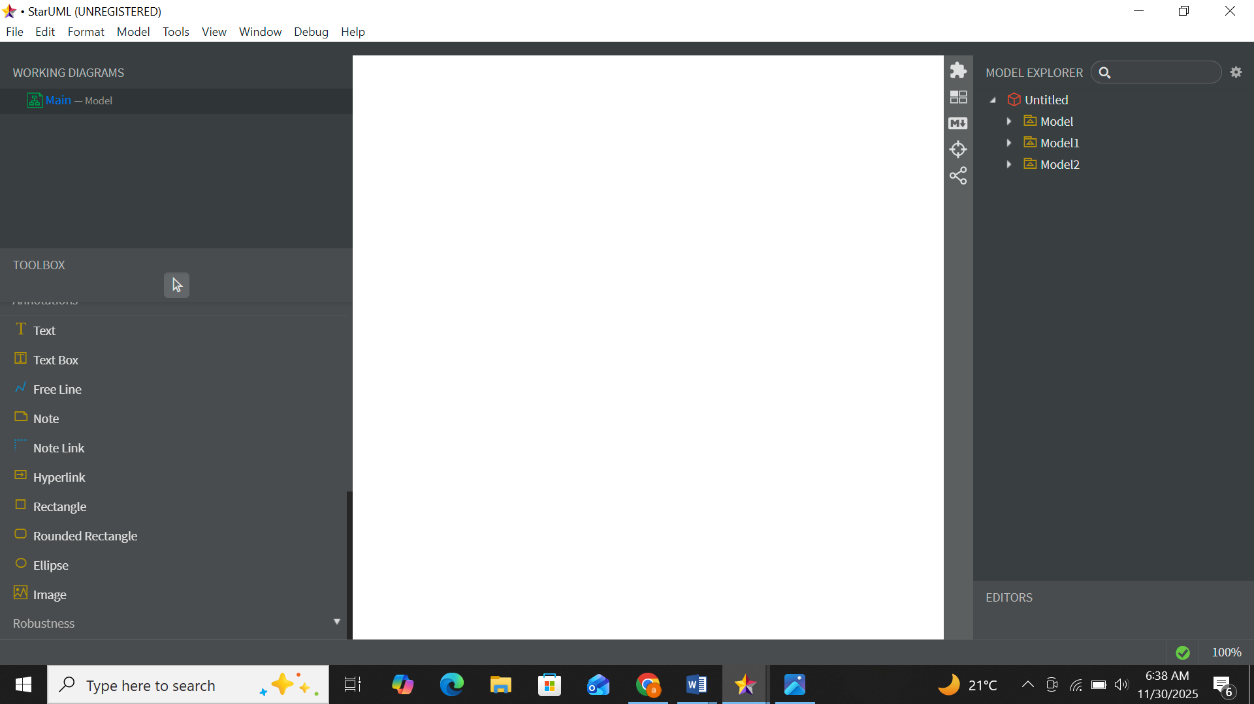

Question # 02: SRS Document in IEEE Format
Prepare a mini SRS document for Online Food Delivery System including:
- Introduction
- Overall Description
- Functional Requirements
- Non-Functional Requirements

Software Requirements Specification (SRS)
Online Food Delivery & Restaurant Management System (OFDRMS)
Prepared by: AYESHA FAISAL
Student ID: 65968
Course: Software Requirement Engineering — KIET
Date: 23-Nov-2025

1. Introduction

1.1 Purpose
This Software Requirements Specification (SRS) describes the complete functional and non-functional requirements for the Online Food Delivery & Restaurant Management System (OFDRMS).
The system will enable customers to browse restaurants, select items, place online orders, make secure payments, track delivery in real time, and rate food and service.
Restaurants will manage menus and order statuses, while delivery personnel will receive delivery requests and update delivery progress.

1.2 Scope
The OFDRMS will:
- Allow customers to browse restaurants and menus.
- Support online food ordering and secure payment processing.
- Assign delivery personnel and enable real-time order tracking.
- Allow restaurants to manage their menus and process orders.
- Maintain complete order history for all users.
The system will be available as a web and mobile application and will integrate with external Payment Gateway and GPS/Maps services.

1.3 Definitions, Acronyms, Abbreviations
- OFDRMS: Online Food Delivery & Restaurant Management System
- UI: User Interface
- API: Application Programming Interface
- ETA: Estimated Time of Arrival
- PCI-DSS: Payment Card Industry – Data Security Standard

2. Overall Description

2.1 Product Perspective
The system follows a multi-tier architecture containing:
- Frontend (Web/Mobile UI)
- Backend Services (Order Manager, User Manager, Payment Service, Delivery Service)
- Database for persistent storage
External dependencies include Payment Gateway APIs and GPS/Mapping services.

2.2 User Classes and Characteristics
- Customer: Can search restaurants, place orders, make payments, and track deliveries.
- Restaurant Manager: Manages menu items, updates stock, accepts/rejects orders.
- Delivery Personnel: Receives delivery requests and updates delivery status.
- Admin: Manages users, monitors overall system performance, handles reports.

2.3 Operating Environment
- Backend deployed on cloud servers (e.g., Linux-based).
- Accessible on modern web browsers and mobile operating systems (Android/iOS).
- All communication through secure HTTPS protocol.

3. Functional Requirements

3.1 User Registration & Authentication
- FR1: The system shall allow users to register an account using email or phone number.
- FR2: The system shall allow users to log in and reset password.

3.2 Browse Restaurants & Menus
- FR3: The system shall allow customers to browse restaurants by category, location, or rating.
- FR4: The system shall allow customers to view menu items, prices, and availability.

3.3 Place Order
- FR5: The system shall allow customers to add items to cart and place an order with delivery details.
- FR6: The system shall generate an order with unique order ID and store order details.

3.4 Process Payment
- FR7: The system shall integrate with a Payment Gateway for online payments.
- FR8: The system shall record payment status (success/failure).

3.5 Order Tracking
- FR9: The system shall allow customers to track delivery personnel location and ETA on a map.

3.6 Ratings & Reviews
- FR10: The system shall allow customers to rate orders and write reviews for restaurants.

3.7 Restaurant & Delivery Operations
- FR11: Restaurants shall accept or reject orders.
- FR12: Delivery personnel shall receive assigned deliveries and update status (Picked, Out for Delivery, Delivered).

3.8 Admin Controls
- FR13: Admin shall view system statistics, orders, and revenue reports.

4. Non-Functional Requirements

4.1 Security
- NFR1: All sensitive user data shall be encrypted in transit and at rest.
- NFR2: Payment handling shall comply with PCI-DSS standards.

4.2 Performance
- NFR3: System shall respond to user actions within 2 seconds under normal load.
- NFR4: Payment processing shall complete within 5 seconds on average.

4.3 Availability
- NFR5: The system shall maintain at least 99.5% uptime.

4.4 Scalability
- NFR6: The system shall support an increasing number of restaurants, customers, and orders without performance drop.

4.5 Usability
- NFR7: The system shall have an easy, intuitive, mobile-friendly interface.
- NFR8: Navigation shall be simple with clear feedback messages.

Appendix A: Assumptions & Dependencies
- Payment Gateway service will remain available.
- GPS/Mapping service will provide accurate coordinates.
- Customers will input correct delivery address.

Appendix B: Traceability Matrix (Optional)
(FRs mapped to test cases and system modules if required.)

Question # 03: Class Diagram
Draw a Class Diagram including at least 5 classes (Customer, Order, Restaurant, Menu, Delivery) with attributes and methods.
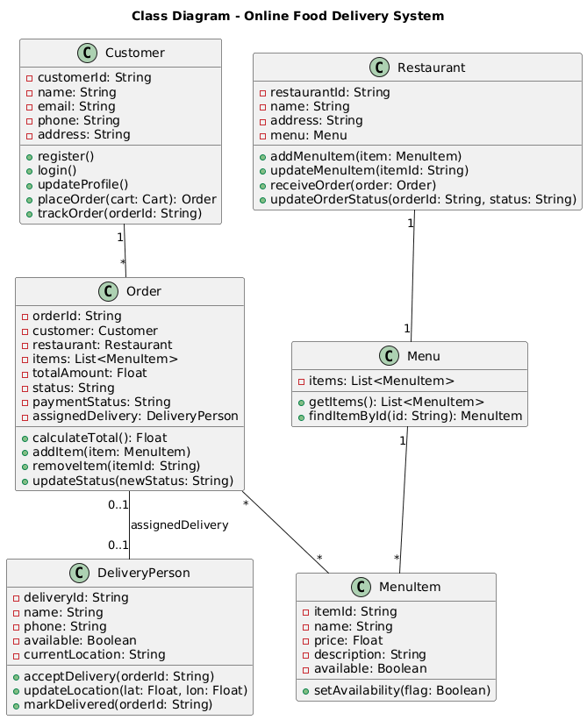
Question # 04: Coding & Git Update
a) Implement a simple console-based program for placing and tracking orders using Python or C#.
CODE:
import uuid
import time
from dataclasses import dataclass, field
from typing import List, Optional

@dataclass
class MenuItem:
id: str
name: str
price: float
available: bool = True

@dataclass
class Restaurant:
id: str
name: str
menu: List[MenuItem]

@dataclass
class Customer:
id: str
name: str
address: str

@dataclass
class DeliveryPerson:
id: str
name: str
available: bool = True
location: str = "Warehouse"

@dataclass
class Order:
id: str
customer_id: str
restaurant_id: str
item_ids: List[str]
total: float
status: str = "Placed" # Placed, Paid, Preparing, OutForDelivery, Delivered, Cancelled
delivery_id: Optional[str] = None

# Sample data
restaurants = [
Restaurant("r1", "Peak Pizza", [
MenuItem("m1","Margherita",8.5),
MenuItem("m2","Pepperoni",9.5),
MenuItem("m3","Garlic Bread",3.0),
]),
Restaurant("r2", "Biryani House", [
MenuItem("m4","Chicken Biryani",7.0),
MenuItem("m5","Mutton Biryani",9.0),
]),
]

delivery_pool = [
DeliveryPerson("d1","Ali"),
DeliveryPerson("d2","Sara"),
]

orders: List[Order] = []

def list_restaurants():
print("\nRestaurants and Menus:")
for r in restaurants:
print(f"{r.id}: {r.name}")
for mi in r.menu:
print(f" {mi.id}: {mi.name} - ${mi.price:.2f} {'(Not available)' if not mi.available else ''}")

def find_restaurant(rid):
for r in restaurants:
if r.id == rid:
return r
return None

def calculate_total(menu, item_ids):
total = 0.0
for it in menu:
if it.id in item_ids and it.available:
total += it.price
return total

def simulate_payment(amount):
print(f"\nProcessing payment of ${amount:.2f} ...")
time.sleep(1) # simulate delay
# Very simple random-free simulation for assignment: always succeed for amounts < 100
if amount < 100:
txn = str(uuid.uuid4())[:8]
print("Payment Success. Transaction ID:", txn)
return True, txn
else:
print("Payment Failed due to amount limit.")
return False, None

def assign_delivery(order: Order):
for d in delivery_pool:
if d.available:
d.available = False
order.delivery_id = d.id
order.status = "OutForDelivery"
print(f"Assigned delivery person: {d.name} (ID: {d.id})")
return d
print("No delivery person available right now.")
return None

def place_order_flow(customer: Customer):
list_restaurants()
rid = input("\nEnter restaurant id to order from: ").strip()
r = find_restaurant(rid)
if not r:
print("Invalid restaurant id.")
return
print(f"\nSelected {r.name}")
print("Enter item ids separated by comma (e.g. m1,m2):")
item_input = input("Items: ").strip()
item_ids = [x.strip() for x in item_input.split(",") if x.strip()]
total = calculate_total(r.menu, item_ids)
if total == 0:
print("No valid items selected or items unavailable.")
return
print(f"Order total: ${total:.2f}")
confirm = input("Confirm and pay? (y/n): ").strip().lower()
if confirm != 'y':
print("Order cancelled by user.")
return
paid, txn = simulate_payment(total)
if not paid:
print("Payment failed. Order not created.")
return
oid = str(uuid.uuid4())[:8]
order = Order(id=oid, customer_id=customer.id, restaurant_id=r.id, item_ids=item_ids, total=total, status="Paid")
orders.append(order)
print(f"Order placed successfully. Order ID: {order.id}")
print("Notifying restaurant...")
time.sleep(0.5)
print("Restaurant acknowledged order.")
assign_delivery(order)

def track_order_flow():
oid = input("\nEnter Order ID to track: ").strip()
for o in orders:
if o.id == oid:
print(f"Order {o.id} | Status: {o.status} | Delivery ID: {o.delivery_id}")
return
print("Order not found.")

def main():
print("Welcome to OFDRMS (Console Demo)")
name = input("Enter your name: ").strip() or "Guest"
addr = input("Enter delivery address: ").strip() or "Unknown"
customer = Customer(id=str(uuid.uuid4())[:8], name=name, address=addr)
while True:
print("\nOptions: 1) Place Order 2) Track Order 3) List Restaurants 4) Exit")
choice = input("Choose: ").strip()
if choice == '1':
place_order_flow(customer)
elif choice == '2':
track_order_flow()
elif choice == '3':
list_restaurants()
elif choice == '4':
print("Goodbye!")
break
else:
print("Invalid option.")

if __name__ == "__main__":
main()

OUTPUT:
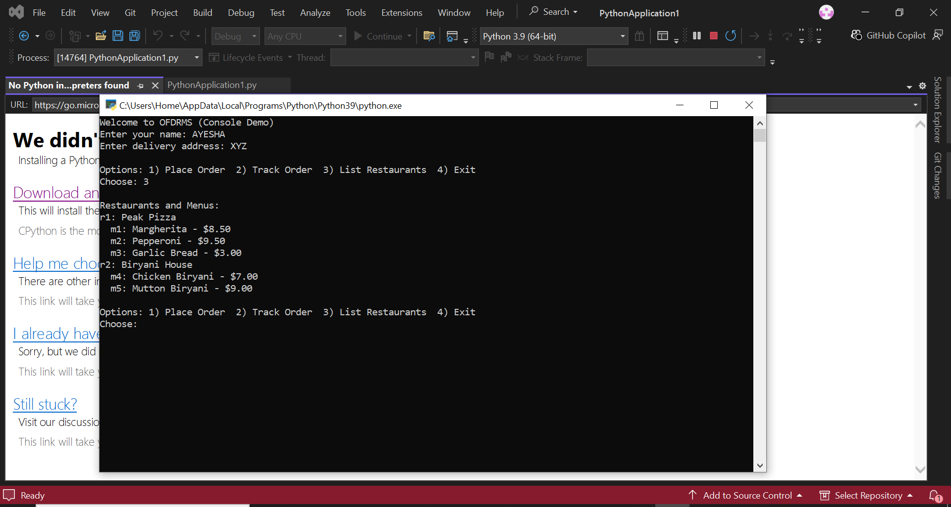
b) Push all diagrams, SRS document, and code to a GitHub repository. Share the repository link
https://github.com/Ayesha-Faisal-30/SRE-LAB-ASSIGNMENT-2-.git

Question # 05: Security Analysis – Vulnerability Assessment
a) Identify at least 3 potential security vulnerabilities in an online food delivery system (e.g., data leaks, payment fraud, and weak authentication).
b) Suggest basic mitigation measures for each vulnerability.

Security Analysis — Vulnerabilities & Mitigations

Vulnerability 1 — Payment Fraud / Stolen Card Data
Risk: Attackers intercept card info during transmission or compromise stored card tokens.
Mitigations: Use tokenization; never store raw card PAN/CVV. Use HTTPS/TLS 1.2+; integrate with PCI-compliant payment gateways; perform transaction monitoring and velocity checks; 3D Secure for high-risk transactions.

Vulnerability 2 — Weak Authentication / Account Takeover
Risk: Weak passwords or credential stuffing lead to user account compromise.
Mitigations: Enforce strong password rules, rate-limit login attempts, implement MFA (OTP/SMS or authenticator apps), and detect abnormal login patterns/international logins.

Vulnerability 3 — Data Leakage from APIs / Insecure Direct Object References (IDOR)
Risk: APIs expose user/order data via predictable IDs or lack authorization checks.
Mitigations: Implement authorization checks at every endpoint, use opaque IDs or tokens, validate session tokens, and use least privilege. Log and monitor API access.
(You can optionally include: XSS in UI and CSRF on forms — mitigate with input validation, Content Security Policy, and anti-CSRF tokens.)

